Frinika
Milestone 3
Team member Student ID
Buthainah Aldosary 6302459
Jagdeep Singh 6449948
Luiz Mauricio Silva 6317006
Mischell Flor 5428483
Seun Odutola 6078109

Class Diagram of Actual System
As previously defined in Milestone 1, the Sequencer GUI component of Frinika is to be evaluated. This section describes the architecture of Frinika’s GUI component, and compares it with the Domain Diagram defined in Milestone 2.
The Domain Diagram is presented in figure 1, while the actual Frinika GUI architecture is presented in figure 2.
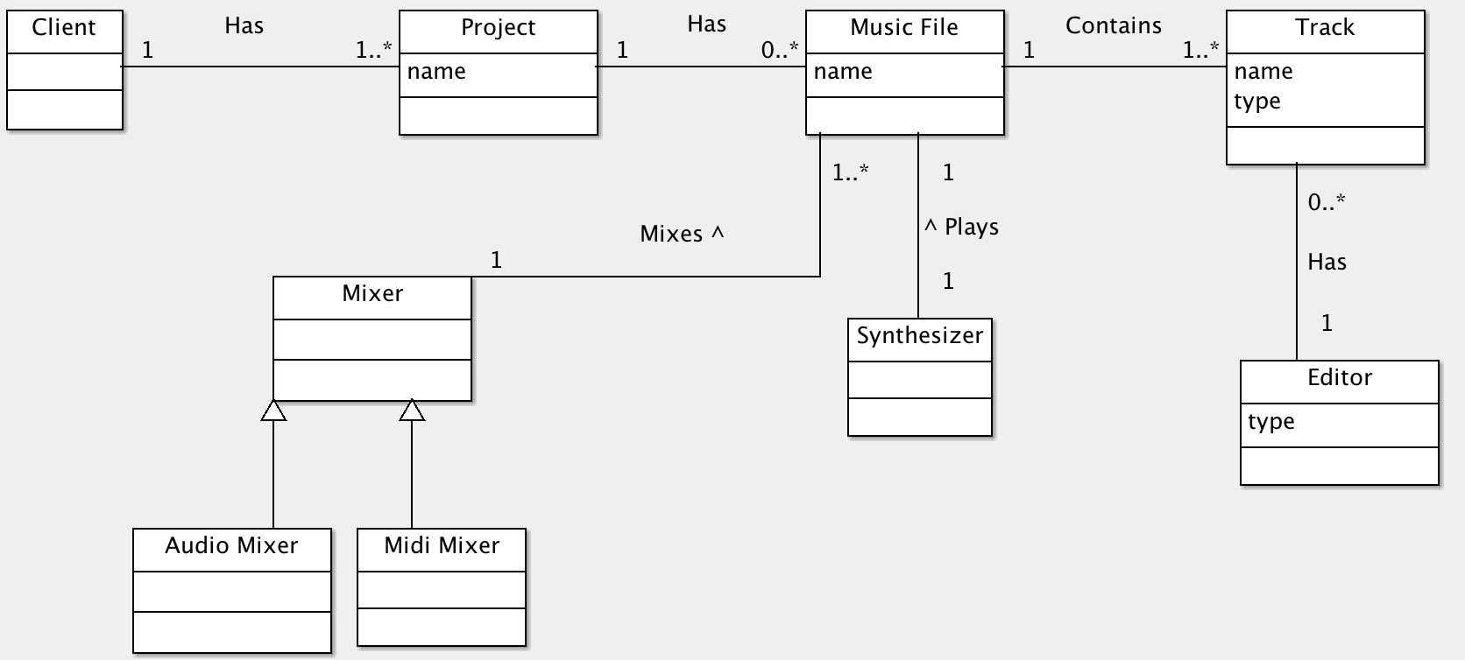
Figure 1: Domain Diagram

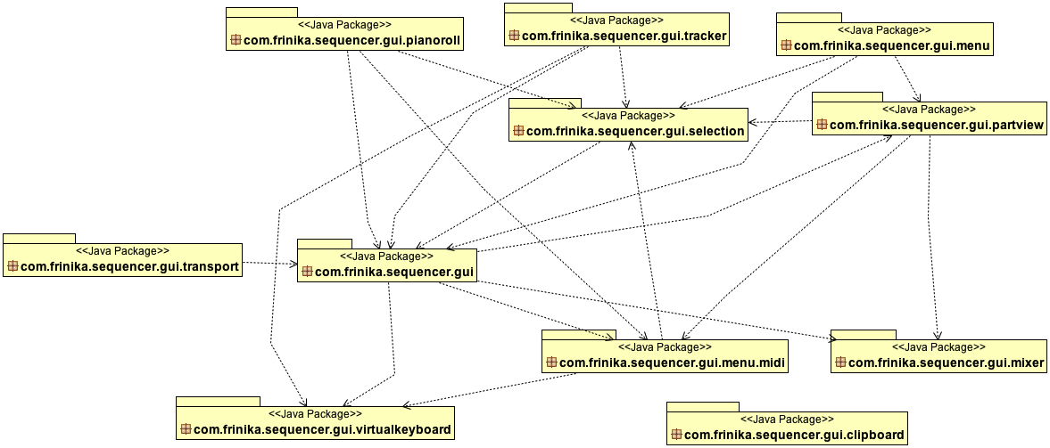
Figure 2: Actual Frinika Architecture, represented by its Package Diagram.
com.frinika.sequence.gui is the root package for the GUI component and all other packages have it as prefix, so they will be referred only by its last denomination, for example, com.frinika.sequencer.gui.traker is referred in this document only as tracker.
Some actual packages can be mapped to concepts defined in the Domain Diagram. For example, pianoroll and tracker are used to edit music tracks with the help of virtualkeyboard, therefore they are subtypes of editors and can be mapped to the concept “Editor” in the Domain Diagram. Other direct mappings can be identified: package mixer maps to the concept Mixer, and packages partview and menu.midi together are mapped to the concept Track.
transport represents the player controls (play, pause, stop, rewind, fast forward) and are actions taken within the Music concept from figure 1. Finally, the package menu loosely represents the concept Project in the Domain Diagram.
However, some packages are not represented at all in figure 1. It is the case of selection, which represents the user selection, of notes or time interval of a music track. Also, clipboard represents notes selected and copied by the user, to be pasted somewhere else. However, this package is not used by the system and could be removed to avoid confusion.

In order to provide a more detailed evaluation of part of Frinika GUI architecture, figures 3 and 4 present the Class Diagrams for two key packages: pianoroll and traker, both used to edit music tracks.
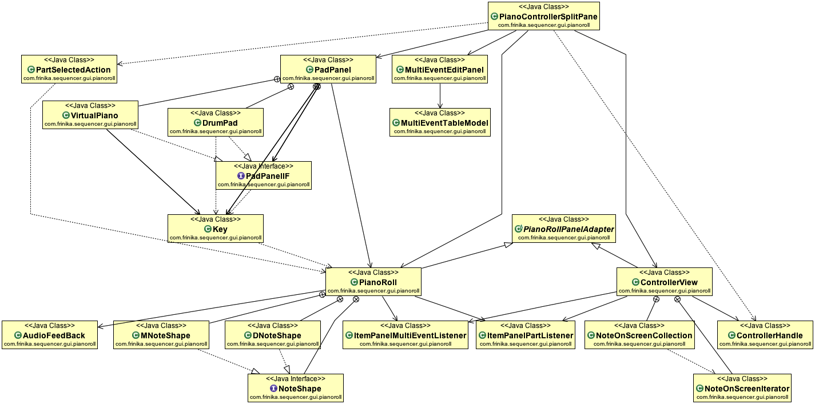
Figure 3: Class Diagram of com.frinika.sequencer.gui.pianoroll

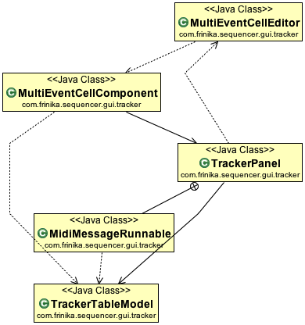
Figure 4: Class Diagram for com.frinika.sequencer.gui.traker

From figure 3, the class VirtualPiano represents piano-like keys where the user (musician) can compose new tracks. It makes use of white and black keys, represented by the class Key. Their relationship is partially depicted next.

The class VirtualPiano has attribute variables of Key vectors, one for while keys and one for black keys, and the constructor Key() is called.

class VirtualPiano implements PadPanelIF {
…
Vector<Key> blackKeys = new Vector<Key>();
Vector<Key> whiteKeys = new Vector<Key>();
…
public void resizeKeys() {
blackKeys.clear();
whiteKeys.clear();

…
int whiteIDs[] = { 0, 2, 4, 5, 7, 9, 11 };
…

// / You will be the size I want . . . .
// setSize(new Dimension(keyDepth, yBot));
// // setMinimumSize(new Dimension(keyDepth, yBot));
// setPreferredSize(new Dimension(keyDepth, yBot));
// setMaximumSize(new Dimension(keyDepth, 20000));
for (int i = 0, y = 0; i < nOctave; i++) {
for (int j = 0; j < 7; j++, y += whiteKeyWidth) {
int keyNum = i * 12 + whiteIDs[j];
if (keyNum >= nNote)
break;
whiteKeys.add(new Key(0, yBot - y, keyDepth, whiteKeyWidth,
keyNum));
}
}
}
…
}
…
}

And finally, the class Key implement the previously invoked methods:
public class Key extends Rectangle {
…
public Key(int x, int y, int width, int height, int num) {
super(x, y, width, height);
kNum = num;
}
…
}

The following reverse engineering tools were used:
- Diver: used to identify the classes used in specific use cases. Even though this information contributed a lot to the understanding of Frinika’s architecture and implementation, it was decided that instead of focusing on use cases, we would focus our efforts on all classes within the packages pianoroll and tracker.
- Object Aid: used to automatically generate package and class diagrams.

Code Smell and Possible Refactoring
This section describes the code smells and related refactorings identified in the packages pianoroll and tracker.
Some Code Smells were identified in Frinika GUI implementation, in different classes:
- PianoRoll
  - Code smell: Large Class (34 methods versus average of ~6.1 methods/class)
  - Code smell: paintImageImpl is a Long Method (180 LOC versus an average of ~8.2 LOC per method; McCabe's Cyclomatic Complexity = 45!!!)
  - Code smell: Switch Statements
- PadPanel
  - Code smell: Primitive Obsession (attributes ON and OFF have integers 0 and 1 assigned to them)
- Key
  - Code smell: Divergent Change (it performs tasks of presentation (GUI) and domain layers)
- ControllerView
  - Code smell: Large Class (33 methods versus average of ~6.1 methods/class)

Therefore, in order to improve cohesion, the following Refactorings can be performed:
PianoRoll
Refactoring: Extract Class, reducing the size and responsibilities of this class (1a).

Key
Refactoring: Separate Domain from Presentation, tackling the issue of Divergent Change (3a).

ControllerView
Refactoring: Extract Class, reducing the size and responsibilities of this class (4a).

Additionally, to improve understandability of the source code, the following refactorings are suggested:

PadPanel
Refactoring: Replace Type Code with Class, replacing the attributes ON an OFF with NoteStatus.ON and NoteStatus.OFF; and replacing Color(0xffeeee), etc with Color.WHITE, Color.BLACK, etc. (2a).

PianoRoll
Refactoring: Extract Method. (1b).
Refactoring: Replace Conditional with Polymorphism, Extract Method and maybe Move Method to a domain class, to be evaluated during refactoring implementation. (1c).

As an example, the Code Smell 1c (Switch Statements) on class VirtualPiano are depicted next.

public class PianoRoll extends PianoRollPanelAdapter {
...
public void dragTo(Point p) {

...
switch (dragMode) {
case OVER_ITEM_MIDDLE:
long tick = ev.getStartTick() + dtick;
int pitch = ((NoteEvent) ev).getNote() + dpitch;
dt = Math.min(dt, tick);
ev.setStartTick(tick);
ev.setNote(pitch);
break;
case OVER_ITEM_RIGHT:
long dur = ev.getDuration() + dtick;
dur = Math.max(1, dur);
ev.setDuration(dur);
break;
case OVER_ITEM_LEFT:
dur = ev.getDuration() - dtick;
long st = ev.getStartTick() + dtick;
dur = Math.max(1, dur);
ev.setDuration(dur);
ev.setStartTick(st);
break;
default:
System.err.println(" unknown dragmode " + dragMode);
}
...
}
...
}

1 – PadPanel
Code-Smell: Large Class
Refactoring: Extract Class, Extract interface.
Solution: PadPanel seems to have a lot of work being done under the hood, it possesses couple of public classes & interface that could well be extracted outside the class to simplify the responsibilities of the class and segregate the distinct functionalities.
Below is a snippet of the class

public class PadPanel extends JPanel implements MouseListener,AdjustmentListener, SelectionListener<Part> {
....
interface PadPanelIF {
void resizeKeys();
void paintComponent(Graphics g);
Key getKey(Point point);
}

class DrumPad implements PadPanelIF {
private static final long serialVersionUID = 1L;
int noteItemHeight;

public void resizeKeys() {
noteItemHeight = Layout.getNoteItemHeight();

yBot = (nNote + 1) * noteItemHeight;
int y = 0;
for (int j = 0; j < nNote; j++, y += noteItemHeight) {
keys[j] = createkey(0, yBot - y, keyDepth, noteItemHeight, j);
}
validate();
}
.....
}

class VirtualPiano implements PadPanelIF {
Vector<Key> blackKeys = new Vector<Key>();
Vector<Key> whiteKeys = new Vector<Key>();
final int nWhiteNote = (nNote / 12) * 7 + 5;
final int nOctave = nNote / 12 + 1;
int whiteKeyWidth, blackKeyDepth = (int) (keyDepth * .6);
int blackWhiteGap;
int noteItemHeight;

public void resizeKeys() {
....
}
.... }

2 - TrackerPanel

Code-Smell: Duplicated Code
Refactoring: Consolidate Conditional Expression , Extract Method

solution: I would group all the if-clauses together using the 'or' operator and then extract them into a method, the method shall be given the name that depicts the operation i.e: IsColumnModelIndexSelected(int index) which returns a boolean.

Code snippet:

public class TrackerPanel extends JPanel implements SelectionListener<Part>,SongPositionListener {

.....

public boolean isColumnSelected(int column) {
if(column == 0) return false;

int c = column - 1;
c = c - c % 4;

if(columnModel.getSelectionModel().isSelectedIndex(c+1)) return true; if(columnModel.getSelectionModel().isSelectedIndex(c+2)) return true;
if(columnModel.getSelectionModel().isSelectedIndex(c+3)) return true;
if(columnModel.getSelectionModel().isSelectedIndex(c+4)) return true;

return false;
//return columnModel.getSelectionModel().isSelectedIndex(column);
}
...
}

- Code Taken from: sequencer\gui\Tracker\MultiEventCellComponent.java

Code Smell: Complicated Conditional statements, Long method

Suggested Refactoring: Decompose Conditional, Extract Method

Steps: I will collect the conditional statement with long method, copy the code and make a new method for it. I will also select the complicated if-else statements (with number of nested if-else) and extract the condition into method. Finally source code will be copied to this method.

CODE:
protected boolean processKeyBinding(KeyStroke ks, KeyEvent e,
int condition, boolean pressed) {
………
if(e.getKeyCode()==KeyEvent.VK_DELETE)
eventValue = EVENT_VALUE_DELETE;
else if(e.isControlDown() && e.getKeyChar()>='0' && e.getKeyChar()<='9')
{
if(pressed)
{
if(this.getText().length() <= 3)
this.setText("CC0"+e.getKeyChar()); else
………
eventValue = EVENT_VALUE_SYSEX;
}
else if(e.getModifiers()==0)
{
………
if(trackerPanel.getAutomaticRowJump()>0 )
{
……//code with try and catch
}
else
{
if(noteKeyThreads[note]==null)
{
if(getReceiver()!=null
…………

- Code Taken from: sequencer\gui\pianoroll\PianoControllersplitpane.java

Code Smell: Long Method

Suggested Refactoring: Extract method

Steps: I will create a new method and name it with the intension of the method. Then I will copy the code from this selected long method to the new target method. This will shorten the method and hence easy to comprehend.

CODE:

public PianoControllerSplitPane(ProjectFrame frame) {
……
final ProjectContainer project = frame.getProjectContainer();
ItemRollToolBar toolBar = new ItemRollToolBar(clients, project);
noteEditPanel = new MultiEventEditPanel(project);
project.getDragList().addFeedbackItemListener(noteEditPanel);
project.getEditHistoryContainer().addEditHistoryListener(noteEditPanel);
project.getMultiEventSelection().addSelectionListener(noteEditPanel);
toolBar.add(noteEditPanel);
Insets insets = new Insets(0, 0, 0, 0);
final WarpToPartLeftAction wpl = new WarpToPartLeftAction(project,
pianoRoll);
………
toolBar.getZoomPanel()).setMargin(insets);
toolBar.getToolsPanel());
bb.setMargin(insets);
bb.addActionListener(new ActionListener(){
………}

